**Date: 25-10-2022 Lecture # 3**

**PROCESS MANAGEMENT**

* Operating System/Kernel decides which process to run.
* We draw process address space (also known as *logical address space*)for each process to visualize it.

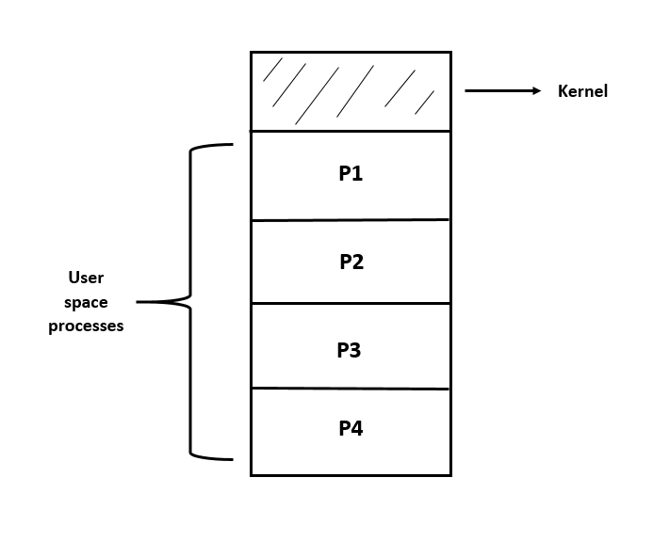

* **TYPES OF PROCESSES:**

There are two types of processes:

1. **I/O Bound Processes:**

* The processes which spend most time in performing I/O events more than CPU computations.
* They use CPU very little.
* **Examples:**
* Printing
* Scanning
* Typing

1. **CPU Bound Processes:**

* The processes which spend most time in performing computations using CPU.
* **Examples:** 
  + - Image comparison
    - Matrix multiplication
    - Mathematical calculations
    - Scientific equations

**2-STATE PROCESS MODEL**

* A Process has usually two states:

1. The process is either running (being executed by CPU).
2. The process is not running (or waiting for an I/O event).

* Here we consider we have only one CPU.

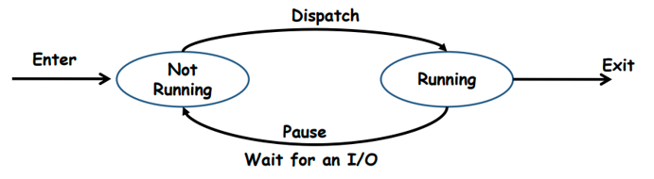

* **Queuing Diagram:**
* Process comes to CPU, it executes it, and then it may exit, or go back to queue.
* CPU does not give infinite time to any process.

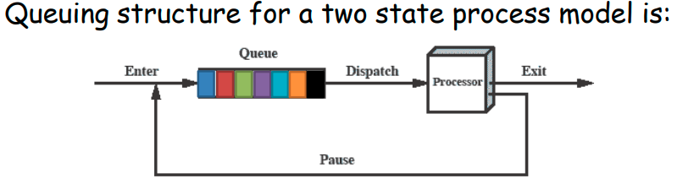

* **Limitations:**
* In this diagram, we consider that all processes in the queue are always ready to execute.
* But there are also some processes waiting for an I/O operation to complete.
* So we create a block queue.
* A scheduler/dispatcher scans for the process which is not blocked and ready to execute.

**5-STATE PROCESS MODEL**

The 5-state process model is important if:

* A process may be waiting for an event to occur.
* A process may be waiting for a resource which is not available at this time.
* Process has gone to sleep for some time.
* So, a Process may be in one of the following five states:

1. **New**: The process is being created
2. **Ready:** The process is in main memory waiting to be assigned to a processor
3. **Running:** Instructions are being executed
4. **Waiting:** The process is waiting for I/O event to occur
5. **Terminated:** The process has finished execution

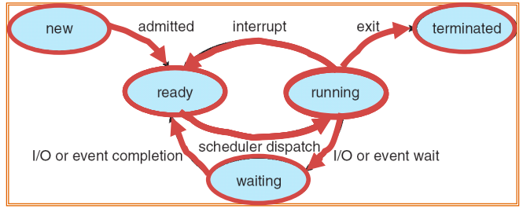

* **Queuing Diagram:**
  + - It consists of 2 queues; one ready queue and one blocked queue.
    - Ready queue is a queue where CPU bound processes wait to execute.
    - Blocked (waiting) queue is a queue where I/O bound processes wait.

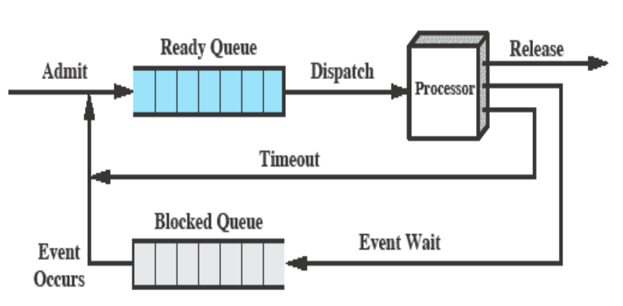

* **Limitations:**
* When an I/O event occurs, the dispatcher would check the entire Blocked Queue to see which process is waiting for that event.
* So,to solve above problem, every I/O device should have its own blocked queue.

**Process Scheduling Queues:**

1. **Job Queue** – This queue consists of all processes in the system. When a process enters the system it is put into a job Queue.
2. **Ready Queue** – This queue consists of processes that are present in main memory and are ready to execute. It is generally stored as a link list.
3. **Device Queues** – This queue consists of processes which are waiting for an I/O event to occur. Each device has its own device queue.

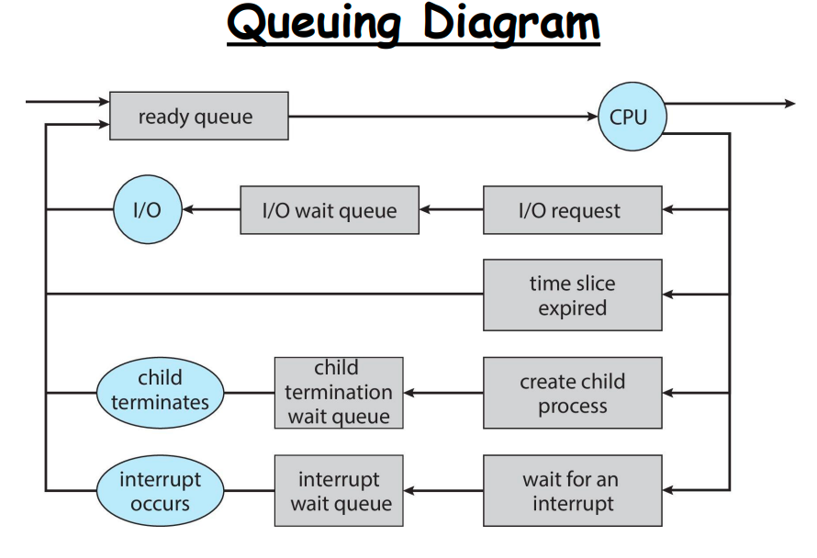

* In UNIX, parent process is responsible for termination of child process.
* **Schedulers:**
  + Every queue has some algorithm to decide which process to run.
  + **Scheduler** is a program which selects a process from various processes.
  + **Dispatcher is a program which takes the selected process to the CPU**
  + **­The condition/base on which scheduler selects the process is called selection criteria.**
  + Types of Schedulers:

1. Long-Term Scheduler
2. Short-Term Scheduler
3. Medium Term Scheduler
4. **Long Term Scheduler:**

* It is not mostly used.
* If all processes selected by LTS are I/O bound, then Ready Queue will be empty.
* If all processes selected by LTS are CPU bound, then I/O waiting queue will be empty.
* LTS is not suitable for multitasking OS.
* Example: Double click on app, FCIT Batch process (once in a year)

1. **Short-Term Scheduler:**

* Also known as “ready queue scheduler” or “CPU scheduler”.
* It is mostly used.
* It selects processes from ready queue.
* **Time quantum:** It is the time assigned to each process to be executed by CPU. This time should not be very high nor low.
* **STS** provides time from 50 msec to 200 msec to each process.

1. **Medium Term Scheduler:**

* Also known as “swapper”.
* CPU execute processes faster than I/O, and processes need to wait for I/O event to occur. In this case, blocked queues become full. So, OS puts a process in suspended queues and transfer it to hard disk.

**7-STATE PROCESS MODEL**

* In this process model, there are two suspended states in hard disk.
* In ready suspended queue, those processes are suspended which are ready but there is time in their execution.
* In blocked suspended queue, those processes are suspended which are waiting for I/O.

